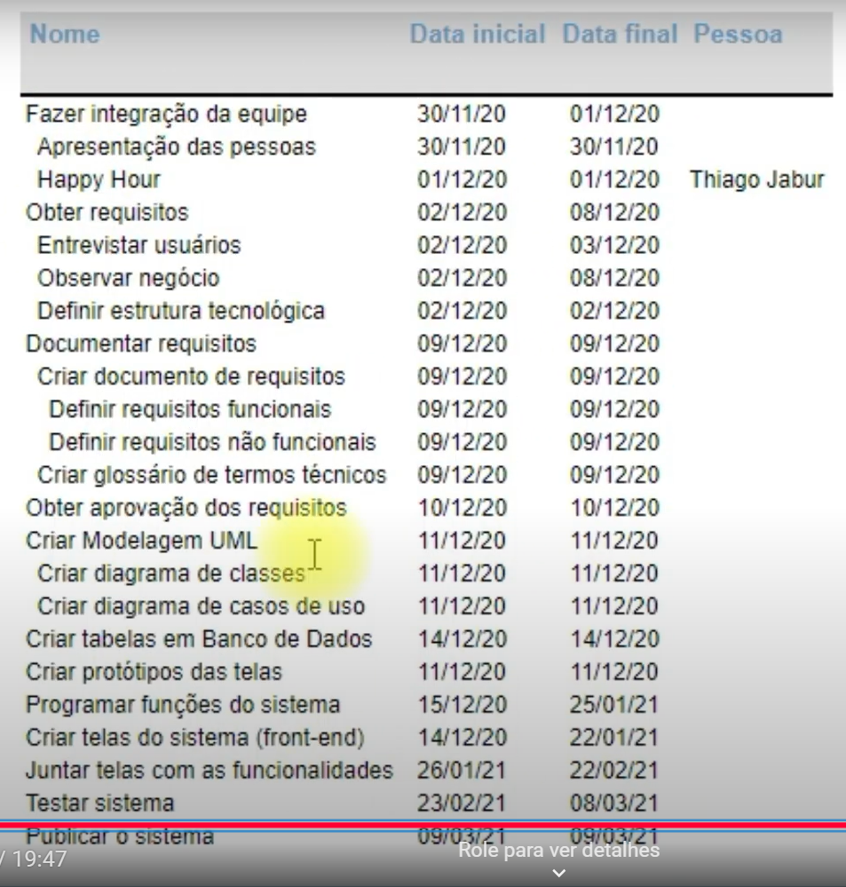

ALINHAR COM SPRINT PLANNING